GÜNEY WİMBA FILLING AND STORAGE FACILITY
DANGEROUS SUBSTANCE
EMERGENCY PLAN

GÜNEY WİMBA FILLING AND WAREHOUSE SERVICES INC.

PREPARED BY: Fatih VARDAR

CONTENTS
1 INTRODUCTION 1
2 PURPOSE 1
3 SCOPE 1
4 EMERGENCY RESPONSIBILITIES 2
4.1 Name, title and contact details of the person/organization preparing the emergency procedures; 2
4.2 Name, title, contact information and duties and responsibilities of the authorized person appointed to coordinate response activities to emergencies that may occur; 2
4.2.1 Duties and responsibilities of the Emergency Manager; 2
4.3 Name, title and contact information, and duties and responsibilities of the facility official who will contact the relevant Port Authority and other relevant institutions and organizations in case of emergency; 2
4.3.1 Duties and responsibilities 2
5 EMERGENCY PROCEDURE 3
5.1 Decision Making; 3
5.2 Protective Actions and Response 3
5.3 Evacuation 4
5.4 Protecting at the Scene 4
6 EMERGENCY RESPONSE ORGANIZATION CHART 5
7 DUTIES AND RESPONSIBILITIES OF TEAMS DETERMINED FOR INTERVENTION IN EMERGENCY SITUATIONS, 6
7.1 Emergency Management Group 6
7.2 Private Security Unit 6
7.3 Fire Team 6
7.4 Search and Rescue Team 6
7.5 First Aid Team 6
7.6 Environmental Accident Emergency Team 7
7.7 Damage Assessment Team 7
7.8 Technical Repair Team 7
8 INVENTORY OF RESOURCES, EQUIPMENT AND HARDWARE TO BE USED TO RESPONSE TO EMERGENCY SITUATIONS 8
9 PRECAUTIONS TO BE TAKEN AND ACTIONS TO BE TAKEN IN ORDER TO CONTROL SERIOUS CONDITIONS THAT ARE FORESEEABLE TO CAUSE EMERGENCY SITUATIONS AND TO MINIMIZE THE NEGATIVE EFFECTS THEY MAY COME TO AND THE FACILITY'S RELATIONSHIPS TO THEM. CURRENT OPPORTUNITIES, CAPABILITIES AND CAPACITY OF 10
9.1 Emergency procedures 10
9.2 Emergency information 10
9.3 Fire precautions 11
9.4 Fire fighting 12
9.5 Environmental precautions 12
9.6 Fighting pollution 12
10 REGULATION REGARDING THE NATURE OF MEASURES AND WARNINGS THAT NEED TO BE TAKEN IN ORDER TO PREVENT OR MINIMIZE POTENTIAL RISKS TO PERSONS AT THE SHORE FACILITY IN THE EVENT OF ANY EMERGENCY AND THE METHODS OF ANNOUNCEMENT AND WHAT PERSONS SHOULD DO IN THE FACE OF A WARNING. LER, 13
11 EMERGENCY EVACUATION PROCEDURE FOR REMOVING SHIPS AND MARINE VESSELS FROM THE SHORE FACILITY IN EMERGENCY CASES 15
11.1 Purpose 15
11.2 Emergency Conditions 15
11.3 Air Opposition 16
11.4 Conditions Requiring Fire or Emergency on Board 17
11.5 Conditions Requiring Fire or Emergency in the Terminal Area 17
11.6 Other Causes 17
11.7 Communication 17
11.8 Emergency Separation System Preparation 18
11.9 Performing Emergency Separation 19
11.10 After Emergency Separation 20
12 Procedures for Initial Notification to the Port Master in Cases of Emergency, the Content of the Information to be Included in this Notification, and Procedures for Transmitting This Information to the Port Master as New Information is Obtained 21
13 IN EMERGENCY CASES, FIRST NOTIFICATION PROCEDURES TO BE MADE TO THE PORT AUTHORITY, THE CONTENT OF THE INFORMATION THAT SHOULD BE PROVIDED IN THIS NOTIFICATION, AND THE PROCEDURES FOR TRANSMITTING THIS INFORMATION TO THE PORT AUTHORITY AS NEW INFORMATION IS OBTAINED 22
TRAININGS THAT SHOULD BE TAKEN BY PERSONNEL WHO WILL WORK IN EMERGENCY SITUATIONS 23
13.1 Personnel 23
13.2 Training content 23
14 COORDINATION METHODS TO BE PROVIDED WITH EMERGENCY TEAMS OUTSIDE THE SHORE FACILITY IN EMERGENCY SITUATIONS 24
15 NATURE AND PERIOD OF DRILLS TO BE CARRIED OUT FOR EMERGENCY SITUATIONS 25
15.1 Training Practices; 25
15.2 Training Scenarios; 25
15.3 Periods 25
16 REGULATIONS TO PROVIDE SUPPORT TO MEASURES TAKEN OUTSIDE THE SHORE FACILITY IN EMERGENCY SITUATIONS 26
17 EMERGENCY APPLICATIONS 27
17.1 Facility, equipment and site fires, 27
17.2 Cargo belonging to each hazardous cargo class and sub-hazard classes that are allowed to be handled in the port fires 28
17.3 Ship fires 29
17.4 Explosion 30
17.5 Accidental death and serious injury, 31
17.6 Natural disasters such as earthquakes, floods, landslides, tsunami waves disasters 32
17.6.1 Flood Action Plan 32
17.6.2 Earthquake Action Plan 33
17.6.3 Lightning Strike Action Plan 34
17.7 Adverse weather such as very strong winds, storms, heavy snow or icing conditions 35
17.7.1 Extreme Cold, Icing and Snow Action Plan 35
17.8 Storm/Hurricane/Tsunami Action Plan 36
17.8.1 Unfavorable Visibility Action Plan 37
17.9 Leakage, flow or leakage of hazardous substances belonging to each hazard class or sub-hazard classes that are allowed to be handled in the port shedding 38
17.10 Marine pollution (for example: oil/fuel leakage or hazardous cargo or environmentally harmful substances entering the sea spill/fall) 39
17.11 Gas leak 40
17.12 Power outage 41
18 ANNEX-1 SITE PLAN 42
19 APPENDIX-2 INTERNAL AND OUTSIDE THE FACILITY COMMUNICATION LIST 43
20 ANNEX-3 ORGANIZATION CHART 44
21 ANNEX-4 DANGEROUS MATERIAL INCIDENT NOTIFICATION FORM 45
22 ANNEX-5 EMERGENCY INTERVENTION AND FIRST AID GUIDE 46
22.1 Loads Handled in Our Port Facility 46
22.2 Ems And Mfag Usage Procedure 46
22.3 Emergency Response and First Aid Guide to Use When SDS Information Is Not Available 53

PLAN DISTRIBUTION AND REVISION RECORDS
DISTRIBUTION PLAN

DISTRIBUTION PLACE | CONTROL NO. | DISTRIBUTION DATE
South Wimba Storage | one | 04.07.2022

REVISION TABLE

REV. DATE | PAGE NO. | CORRECTION SUBJECT | CORRECTION BY | REASON
13.03.2024 | 60 | Contact updates | İbrahim Altınbaş | Update

ENTRANCE
This plan has been prepared in accordance with the provisions of the Regulation on the Transport of Dangerous Goods by Sea published in the Official Gazette dated 3/3/2015 and numbered 29284 and the Directive on Issuing a Dangerous Goods Conformity Certificate and will be revised at least every 3 years.

AIM
Minimizing and controlling the negative effects arising from emergencies that may occur, Preventing or minimizing the negative effects on life, property and environmental safety, Taking necessary precautions to protect human health and the environment, Transmitting the necessary information to the relevant institutions/organizations, Requiring necessary information after the accident provision of restoration operations.

SCOPE
It covers the prevention of incidents involving hazardous substances in the following emergency situations, minimizing the damage to the environment and intervention, and post-event improvements.
1. Facility, equipment and field fires,
2. Cargo fires belonging to each hazardous cargo class and sub-hazard classes that are allowed to be handled in the port,
3. Ship Fires,
4. Explosion,
5. Accidental death and serious injury,
6. Natural disasters such as earthquakes, floods, landslides, tsunami waves,
7. Adverse weather conditions such as very strong wind, storm, excessive snow or icing,
8. Leakage, flow or spillage of hazardous substances belonging to each hazard class or sub-hazard classes that are allowed to be handled in the port,
9. Marine pollution,
10. Gas leak,
11. Power outage.

EMERGENCY RESPONSIBILITIES

Name, title and contact details of the person/organization preparing the emergency procedures;
Name of the Prepared Person/Organization : TEPE SAVUNMA VE GÜVENLİK SİS.SAN.A.Ş.
Title of Person/Organization : Fatih VARDAR
Contact Details:
Phone Number : 05414583709
E-mail address : fatih.vardar@tepesavunma.com.tr

Name, title and contact information, and duties and responsibilities of the authorized person appointed to coordinate response activities to emergencies that may occur;
Name of Authorized Person : Doğan ÖREN
Title of the Authorized Person : Facility Manager
Contact Details
Phone Number : 0531 463 96 30
E-mail address : dogan.oren@guneywimba.com.tr

Duties and responsibilities of the Emergency Manager;
Intervention methods during and after an emergency and the continuation, stopping, etc. of work related to the Port. It decides to implement the decisions by taking them with the Emergency Management Group.

Name, title and contact information, and duties and responsibilities of the facility official who will contact the relevant Port Authority and other relevant institutions and organizations in case of emergency;
Name of Authorized Person : İbrahim ALTINBAŞ
Title of the Authorized Person : Facility Assistant Manager.
Contact Details
Phone Number : 0539 426 48 59
E-mail address : ibrahim.altinbas@guneywimba.com.tr

Duties and responsibilities
It is responsible for making the first notification to the Port Authority and Civil Authorities, making notifications in accordance with the ANNEX-4 format in the future and transmitting new information as it becomes available.

EMERGENCY PROCEDURE

To decide ;
The preventive measures options for a particular situation depend on a number of factors. In some cases, evacuation may be the best option. In other cases, sheltering in place may be the best option. Sometimes, these two actions can be used together. In any emergency situation, authorities need to quickly issue instructions to the people involved. Subjects will need to constantly hear information and instructions while being sheltered or evacuated at the scene.

Proper evacuation of the following elements will determine the degree of effectiveness of evacuation or containment at the scene. The severity of these factors may vary depending on emergency conditions. In emergency situations, other elements may also need to be identified and taken into account. This list shows what kind of information may be needed to make an initial decision.
Dangerous materials
Degree of harm to health
Chemical and physical properties
Quantity included
Control of hold/release
Rate of steam movement
Population Exposed to Threat
where they are located
Number of people
Time available to evacuate or take control of their location
Possibility to control evacuation or protection at the location
Types and availability of buildings
Specific organizations and populations.
Weather conditions
Effect on vapor and cloud movement
Potential for change
Impact on evacuation or in-situ protection

Protective Actions and Response
Protective Measures refer to the steps to be taken to protect the health and safety of emergency teams and people in the incident area in the event of an incident involving dangerous substances, and action is taken in accordance with the Emergency Response Guide prepared according to the characteristics of the hazardous substance specified in the ANNEX.
Isolating the Danger Area and Prohibiting Entry, anyone who will not directly participate in emergency response operations should be kept away from the area. Emergency response teams without adequate equipment should not be allowed to enter the isolated area.

Evacuation
Evacuate: Indicates that everyone should be moved from a threatened area to a safer location. Before an evacuation can take place, there must be enough time for people to be warned, prepare, and leave the area. If there is sufficient time, then evacuation is the best protective measure.
First of all, people who are nearby and within sight should be evacuated. When additional help arrives, upwind and downwind areas will be evacuated at least to the extent specified in the Emergency Response Guide specified in the Annex.
Even after people have been evacuated to recommended distances, they may not be completely safe from danger. These people will not be allowed to gather together at these distances.
Evacuees will be transported to a certain distance, on a special route, and at a distance where they will not need to be evacuated again when the wind blows.

Protecting at the Scene
It means that people should take protection inside a building and stay inside until the danger is over. Protective measures at the scene are applied when trying to evacuate people poses a greater risk than keeping them where they are, or if evacuation is not possible. Persons inside will be instructed to close all doors and windows and turn off all ventilation, heating and cooling systems.
On-scene protection is not the best precaution when:
If the vapors are flammable;
If it will take a long time for the area to be degassed.
If buildings cannot be tightly closed.
Vehicles can provide some protection for a short period of time if windows are closed and ventilation systems are turned off. However, vehicles are still not as safe as buildings in terms of on-site protection.
It is vitally important to maintain communication with competent people within the building to be able to advise on changing conditions. Persons under shelter in place should be warned to stay away from windows, as there is a risk of being hit by glass or metal fragments in the event of a fire and/or explosion.
Every incident involving hazardous materials is different from each other. There are separate problems and concerns regarding each of these. The form of action aimed at protecting people must be chosen carefully.

EMERGENCY RESPONSE ORGANIZATION CHART

DUTIES AND RESPONSIBILITIES OF TEAMS DETERMINED FOR INTERVENTION IN EMERGENCY SITUATIONS,

Emergency Management Group
To take the necessary instructions and decisions to ensure that the interventions to be made in the facility are carried out in the most effective and rapid manner during and after an emergency. To create plans to ensure the operation of the facility after the emergency.

Private Security Unit
It is the responsibility of ensuring the security of the facility directly during and after the emergency and accelerating the process by taking the necessary security measures for the interventions and operations carried out in the facility.

SPECIAL SECURITY UNIT
İsmail KARLIDAĞ
Suleyman TEKIN
Muzaffer KURT

Fire Team
In case of any fire that occurs in the facility, the aim is to intervene in the fire in the best way possible as soon as possible, to extinguish it if it is of extinguishable size, and to keep it under control until the fire response teams requested from other organizations arrive if it is a larger fire.

FIRE TEAM
Ali Gökhan İPEK
Mehmet GÖK
Ferhat KARACA

Search and Rescue Team
After any emergency that occurs in the facility, it is responsible for rescuing any person trapped in the facility in the healthiest and fastest way, using all equipment, based on the information received by the evacuation and assembly area managers.
SEARCH AND RESCUE TEAM
Ömer ÖZDEMİR
Mustafa ASLAN

First Aid Team
intervene in the most appropriate way at the scene of the injured person after an incident that causes a health problem in the facility, and to make him/her suitable for referral to other health institutions in cases where intervention cannot be done .
FIRST AID TEAM
Mehmet ALTINBAŞ

Environmental Accident Emergency Team
To intervene as soon as possible and in the best possible way to protect the environment against chemical leaks or spills that may occur during or after an emergency in the facility. To ensure that precautions are taken against environmental pollution that may occur subsequently.
ENVIRONMENTAL ACCIDENT EMERGENCY TEAM/AT SEA
ENVIRONMENTAL ACCIDENT EMERGENCY TEAM/ON LAND
Mehmet EYYÜPOĞLU | Kadir OZER
Fatih AKKURT

Damage Assessment Team
Building, equipment, etc. that occurs as soon as possible after any emergency that occurs in the facility and damages the facility. detecting damages and reporting them to the technical team.
DAMAGE ASSESSMENT TEAM = Serdar ALTUNBAY

Technical Repair Team
To ensure the operation of the energy equipment (generator, etc.) required for the facility during and after the emergency. To repair the damages occurring within the facility as much as conditions allow. To check the technical equipment in the facility after any emergency that occurs, to ensure the repair of the damaged ones, and to ensure the operation of the necessary equipment (generators, etc.) to continue the emergency interventions after the emergency. is to provide.
It is to cut off the electricity, natural gas and hazardous chemical lines going to the emergency area and put the pump rooms into operation.
TECHNICAL REPAIR TEAM
Mehmet GÖK
Dogan ÖREN
İbrahim ALTINBAŞ

INVENTORY OF RESOURCES, EQUIPMENT AND HARDWARE TO BE USED TO RESPOND TO EMERGENCY SITUATIONS

FIRE INTERVENTION MATERIAL INVENTORY
50kg kg ysc fire extinguisher
12 kg YSC fire extinguisher
5kg ysc CO2
Hy pvc Red Hose
Sahara type fire cabinet
Lance Controlled
Foam Makers
Foam Tanks

INVENTORY OF MATERIALS TO BE USED IN CASE OF FUEL LEAK
EQUIPMENT | UNIT | AMOUNT
fat absorbing sausage
oil absorbent pad | 100mt*100mt | one
shoes for work | 1 pair | 5
Boot | 1 pair | 10
Raincoat | 1 pair | 5
Tayvek jumpsuit | one | 6
Glove | 1pair | 5
half face mask | one | 20
Goggles | one | 10
Gasmask | one | 5
work overalls | one | 5
Anchor | one | 2
Rope | 100m | one
Skimmer (Oil scraper) | one | 2
floating collection tank | 100m3 | one
hard hat | one | 3
Buoy | one | one
Hose | 5m | 2
power unit | one | one
hydraulic hose | 5m | 2

FIRST AID SUPPLIES LIST
Flexible Medical Patch | 2
Stril Gauze | 2
Isotonic sodium chloride solution | 2
Scissors | 2
cloth bandage | 2
Arveles pharmaceutical | 2
Fucidin ointment | 2
Oxygenated Water | 2
Powdered latex gloves | 2
Tweezers | 2
Syringe with Needle | 2
Cotton | 2
Elastic bandage | 2
Eye drop | 2

PRECAUTIONS TO BE TAKEN AND ACTIONS TO BE TAKEN IN ORDER TO CONTROL SERIOUS CONDITIONS THAT ARE FORESEEABLE TO CAUSE EMERGENCY SITUATIONS AND TO MINIMIZE THE NEGATIVE EFFECTS THEY MAY COME TO, AND THE FACILITY'S REGULATIONS REGARDING THEM. AVAILABLE OPPORTUNITIES, CAPABILITIES AND CAPACITY,

emergency operations
It will be ensured that appropriate emergency arrangements are made and notified to those concerned. These regulations will include the following.
- Providing appropriate emergency alarm operating points;
- Reporting an incident or emergency to the relevant emergency services within and outside the port area;
- Notifying the port administration and port area users at sea and on land of an incident or emergency;
- Providing emergency vehicles suitable for the hazards of the dangerous loads to be handled;
- Coordinated arrangements for the departure of a ship in the event of an emergency;
- Arrangements to ensure adequate access/egress at all times;
- The necessity of organizing a safe and rapid emergency escape plan, taking into account the nature of the dangerous cargo and all its special conditions;
- Utilizing the "Medical First Aid Guide (MFAG)" in the annex of the IMDG Code in order to provide the necessary medical first aid to people affected by the damages of dangerous cargoes and to health problems that occur as a result of accidents involving these cargoes;
- Utilizing the "Emergency Plans (EmS)" in the IMDG Code annex regarding emergencies involving dangerous cargoes;
- In case of emergencies or accidents, first aid materials to be used for intervention should be kept by the personnel in known and easily accessible places;

emergency information
- including port facility quantities, Proper Shipping Names, correct technical names (if applicable) UN numbers, classes or division of goods, where assigned, Class 1, compatibility group inscription, adverse hazard classes (if assigned) packing group (if assigned) and A list of all hazardous cargo in warehouses and other areas shall be provided, including its exact location, kept readily available for emergency services.
- The person responsible for warehouses and areas where hazardous cargo handling takes place will be aware of the occupancy status of hazardous cargo in his/her area and will have information available for use in case of emergency.
- the necessary information about the measures to be taken to handle accidents related to dangerous cargo and will have this information available for use in emergency situations.
- It will be ensured that emergency response procedures and emergency phone numbers are located within the facility, within the warehouses and areas where dangerous goods transportation and operations are carried out, or in important locations of these places.
- Fire-fighting and pollution-fighting equipment and equipment will be clearly marked, and announcements drawing attention to them will be clearly visible in all appropriate places.
- Information about the emergency procedures in effect and the services available at the interface will be given to the captain of the ship loading or carrying dangerous cargo.

Fire precautions
- All parts of the mooring area at the interface where the ships berth will always be accessible to emergency services.
- Audible or visual alarms will be provided within the area for emergency use.
- Communication tools will be available for emergency services.
- All areas used for the transportation of dangerous goods will be kept clean and tidy.
- The ship captain will be informed about how to call emergency services before loading dangerous cargo.
- In areas where hazardous loads are at the interface, lighting and other electrical equipment that is safe to use in flammable or explosive environments will be used.
- It will be ensured that portable electrical equipment that is safe for use in a flammable environment is used in this area.
- Places where smoking is prohibited will be determined.
- Warnings in the form of symbols prohibiting smoking will be clearly visible at every point, and smoking areas will be kept at a safe distance from places where they may pose a danger.
- Equipment used in a flammable or explosive environment or in an area or space in an environment where such conditions may develop shall be safe for use in a flammable or explosive environment and shall not cause any fire or explosion and shall be suitable for use in this way.
- Considering the fire and explosion hazards that may occur as a result of transportation of hazardous loads, it will be taken into account that empty load transport units may still contain residues and flammable vapors and may be dangerous.
- Electrical equipment plugged into portable plugs with extended cables shall not be used in areas or places that may create a flammable atmosphere.

fire fighting
- Adequate and accurately tested fire extinguishing equipment and facilities will be available on board.
- Adequate equipment will be available in areas where dangerous goods are transported or loaded.
- Personnel involved in the transportation or loading of dangerous goods will be trained in the use of fire extinguishing equipment.

Environmental precautions
Dangerous loads will be transported in appropriate areas.
Damaged cargo or cargo transport unit containing dangerous cargo will be dealt with appropriately, and such dangerous cargo will not be allowed to be transported or transported unless it is made suitable and safe for transportation.
If necessary, the damaged load or load transport unit containing dangerous loads will be transported to the area designated for these loads.
Spilled dangerous cargo will not be swept or washed and thrown into the sea. The cargo in question will be prevented from going to the sea with rainwater.
During the loading and unloading of bulk cargoes from the ship, necessary precautions will be taken to avoid spilling cargo into the sea. These precautions are also taken during limbo operations.
Necessary measures will be taken to prevent hazardous materials handled at the coastal facility from contaminating the soil, water or areas where water is discharged. These measures also apply to areas with pipelines and conveyor systems used for the handling of hazardous substances.
Contaminated bilge water, dirty ballast, sludge, slop and cargo waste will be picked up from the ship.

fight pollution
Adequate equipment will be provided to minimize the damage that may occur in case of spillage of hazardous cargo.
Equipment will include oil spill containment fences, condensate caps, absorbent and neutralizing agents, as well as cleanup materials and portable catch basins.
It will be ensured that the personnel involved in the transportation and transportation of hazardous loads are trained and experienced in the use of pollution-fighting equipment in accordance with the Administration's requirements.

The facilities and capabilities of the port facility are specified in Article 8.

REGULATIONS REGARDING THE NATURE OF MEASURES AND WARNINGS THAT NEED TO BE TAKEN IN ORDER TO PREVENT OR MINIMIZE POTENTIAL RISKS TO PERSONS AT THE SHORE FACILITY IN ANY EMERGENCY AND THE METHODS OF ANNOUNCEMENT AND WHAT PERSONS SHOULD DO IN THE FACE OF A WARNING,

If an Emergency Situation occurs or signs of it are detected in the Port, the Emergency Manager initiates taking appropriate measures in accordance with the relevant plans. Emergency Management reviews and implements the decisions regarding the measures to be taken within the scope of the Emergency Procedure, ISGOTT and IMDG Code. It also ensures that the measures specified in the Emergency Response table specified in ANNEX-5 are taken. Developments are constantly monitored and, if necessary, decisions are made to take higher-level measures or receive assistance.
Emergency Management studies will be carried out in the Emergency Management Center or in areas equivalent to this center. Emergency management at different levels depending on the severity of the emergency:
Facility / Field
Institutions
District Emergency Management Center
Provincial Emergency Management Center
It can be managed by the central administration.

Communication channels to determine communication methods within the port and outside the facility in case of emergencies that may occur at the port facility and to effectively manage emergencies;
• Fixed Mobile Phones
• Computers
• Wireless
• Siren
• Designated as messengers
In case of emergency in the port, internal communication will be provided primarily through radios and intercoms. Port-to-Ship communication will be maintained via the radio provided by the Port or VHF marine band radio.
Secure communication with official authorities, neighboring facilities and relevant parties will be provided as soon as possible by telephone or radio. Contact information is in APPENDIX-2.

Facility level Emergency Management; It will be maintained by using a well-designed organization, personnel equipped with training and exercises, Emergency Plans containing procedures and documentation, and safe, fast internal and external communication facilities. In Emergency Management, the process will be monitored and controlled by basically implementing the following measures.

ACTIONS TO BE TAKEN | Related Sections
WARNING: Notifying that an emergency and unexpected situation has occurred/the probability of occurrence has increased. | All Personnel and Ship
CALLING FOR HELP: Reaching out to relevant institutions and transferring the necessary information | All Staff
INTERVENTION: Responding to the Emergency Situation as soon as possible with the correct equipment and trained personnel specified in the Plan. | response teams
FIRST AID: Performing first aid activities until professional support teams arrive. | All First Aid Trained Staff
RECOVERY: Rescue of materials, tools, information, documents and other important documents belonging to the Port Facility | First Aid Personnel
PROTECTION : Protecting the recovered materials, tools, information, documents and other important documents. | Security personal
INFORMATION : Sending necessary explanations to customers, other business contacts and the press. | Management
MANDATORY NOTIFICATIONS: Sending notifications required to be made to public authorities in accordance with the legislation | Management

EMERGENCY EVACUATION PROCEDURE FOR REMOVING SHIPS AND MARINE VESSELS FROM THE SHORE FACILITY IN EMERGENCY SITUATIONS

Aim
The purpose of this procedure prepared for the evacuation of ships from the Sea Systems is to explain the determination of the order of operations required for the most appropriate separation of ships from the Sea Systems in the following emergency situations and the determination of responsibilities.

Emergency Conditions
Port Facility Conditions that require the urgent departure of ships connected to marine systems are stated below.

- adverse weather conditions

- Conditions requiring fire or emergency on board

- Conditions requiring fire or emergency at the Port Facility site

- Other reasons

- Fire breaks out on the ship or facility located in other facilities

- terrorist acts

- War Situation

- Natural disasters

- Situations deemed necessary by Official Institutions

- Pollution

- Deterioration of ship position

- Malfunction on the ship

- medical problems

Air Opposition

Weather conditions | Operation | Action to be taken | Descriptions
Wind > 20  knots | Approach | Ship 's docking  it is not allowed
Wind > 15  knots | Evacuation | Evacuation is stopped. | carries out evacuation until the wind speed drops below < 15 kts.  reserves the right not to restart .
Wind > 20  knots | Evacuation | Flexible hose connections are separated | increase of wind speed and sufficient  Considering the availability of Port Facility Personnel, necessary precautions will be taken to separate flexible hoses safely .
Wind > 30  knots | Evacuation | The Ship Leaves the Buoy. | The decision will be made by the Ship Captain and the Port Facility Representative, under the consultancy of the Pilot.
any  wind speed | Docking Evacuation |  | Port Facility, to ensure its own safety  any action during docking, departure and evacuation and request the ship to implement this decision.
LIGHTNING | EVACUATION | Evacuation is stopped,  All valves of the ship  and vents are closed.  Cargo tank pressures  by watching closely  uncontrolled vent operation  is prevented. | If Yıldırım Port Facility area  If it is in the immediate vicinity.
lying on side  > 2 °  Fore - aft inclination​  > 2.0m | EVACUATION | Evacuation is stopped,  all drain valves  is closed. | The ship takes corrective measures  is desired.
in the table above are calculated and given to ensure safe operation of ships in Port Facility Marine Systems. When the wind speed exceeds 35 kts, the ship is removed from the Marine Systems for ship and facility safety.

Conditions Requiring Fire or Emergency on Board

The start of a fire, which may occur on Ships connected to Marine Systems and may grow larger and get out of control even if it is fought, is a situation that requires the emergency stop of the operation and the separation of the Ship. In addition, in cases where there is an unstoppable leak/spill into the atmosphere, such as a break or split in any ship tank or pipeline, the Ship connected to the Marine Systems must be immediately removed from the Marine Systems in order to prevent damage to the Port Facility and its surroundings.

Conditions Requiring Fire or Emergency in the Terminal Area

In cases such as fire, uncontrollable leaks or conditions that require an emergency within the Port Facility, the ship is urgently removed from the Marine Systems for the sake of ship and environmental safety. Easily extinguishable fires and leaks that will not affect the operation within the Port Facility will be evaluated by the Emergency Management Center and a decision will be made to separate the Ship in the Marine Systems.

Other Causes
In cases where such situations are not directly caused by the ship and the Port Facility, but there is a possibility of damage to the ship indirectly,
• A fire or explosion occurs on a ship or facility located in other facilities,
• Terrorist acts
• War situation
• Natural disasters
• Situations deemed necessary by the state.
• Pollution
• Deterioration of the ship's position
• Occurrence of mechanical failures on the ship side
• Medical problems that will affect the Ship and Port Facility

Ships are urgently removed from the Sea Systems to which they are connected.

Communication

Fast, Secure and uninterrupted communication between the Port Facility and the Ship or between the Port Facility, the Ship and the relevant Authorities when the above-mentioned emergencies occur, will be provided by the communication tools specified below.
- UHF Radio
- VHF Radio
- Mobile phone
- Land phone
- Reporter / Liaison staff

ALARM REASON | ALARM TOOL | SOUND WARNING
Fire in the facility | Wireless phone | Fire in Facility | Fire in the Facility
on the buoy  fire break out | Wireless phone | Fire in Buoy | on the buoy  Fire
Power Cut | Wireless phone | Power Failure | Attention: power outage
Emergency | Wireless phone | Emergency Shutdown | Attention Shutdown System has been activated

Emergency Separation System Preparation

All emergencies must be reported to the Port Authority authorities. If it is decided to leave the ship urgently, the Port Authority must specify safe places where the ship can be transported under controlled conditions.
In cases requiring urgent separation, the ship captain and the Port facility will initiate the emergency separation process by mutual agreement and report the situation to the Port Authority as soon as possible. In cases where the severity of the emergency and time permits, before the emergency separation process is carried out, a representative from the Port Authority or the Port President, Port Manager / Operations Manager, Ship Captain, Pilot Captain will agree on the time and manner of the separation process.
The ship's machinery, steering gear and Marine System break equipment will be made ready for immediate use.
All cargo unloading and ballasting operations must be stopped and preparations will be made for sorting.
The ship's fire circuit will be flooded and water fog will be used for strategic sections.
If venting to the atmosphere is required, engine room personnel must be ready, all non-essential receiver inlets must be closed, all safety precautions relevant to normal operations must be observed, and a warning notice must be issued.
All emergencies will be reported immediately to the local police or fire department if the necessary response exceeds the terminal's capabilities.
Although the decision to lift the ship under control is based on the principle of life safety, it will also include the following conditions.
.1 Adequacy of tugs
.2 Ability of the ship to take off under its own power
.3 Availability of safe places to which a Ship in emergency may proceed or withdraw.
.4 Fire fighting proficiency
.5 Proximity of other ships
.6 Fire Ropes
As long as the ship is in the Port facility, fire ropes will be kept on the bow and shoulders of the ship on the sea side. (For Bulk Liquid Cargo Ships) The eye of the ropes should be lowered to sea level and the part above the side will be tightened by wrapping it around the bollard for at least five turns. The part of the rope above the board will be taut from the bollard. A rope that can carry the rope will be tied just before the eye of the rope and the eye of the rope will be positioned three meters above sea level. While the ship is in the Port facility, the eye of the rope will always be maintained at this level.

Performing Emergency Separation
If all the above preparations are examined and deemed appropriate, the urgent removal of the ship will begin.
Emergency Separation operations will be ensured by performing the following procedures in order.
At each stage, close coordination and cooperation between the Port Facility, the Ship and the Port Authority is required.
Emergency Booking Procedures are below.
.1 Raising an alarm
.2 Vhf, providing information about an emergency via telephone
.3 Conducting an initial situation assessment between the ship captain and the Port Facility official
.4 Cessation of operation
.5 Implementation of Port Facility and ship emergency plan measures
.6 Deterioration of the current situation and the existence of the above-mentioned emergency separation conditions.
.8 Carrying out a situation assessment between the ship captain, port facility authority, port authority or Harbor Master and pilot.
.9 Decision to make urgent separation
.10 Notifying surrounding facilities and other vessels
.11 Positioning of tugboats around the ship for emergency separation, completing their preparations and indicating readiness
.12 The captain of the ship completes the preparations for the ship and states that it is ready.
.13 Approval to open the release hooks by the authorized person
ATTENTION !
IMPLEMENTATION OF THE SHIP'S EMERGENCY SEPARATION PROCESS AS A LAST RESORT
CONSIDERATION SHOULD BE CONSIDERED AND RELEASE HOOKS SHOULD NOT BE RELEASED UNTIL ALL PRECAUTIONS ARE TAKEN AND THE ABOVE CONDITIONS ARE FULFILLED.

After Emergency Separation

After the ship separation process, the ship is towed and the location where it will be taken is decided and declared,
Transfer / mooring of the ship to the allocated area accompanied by tugboats or with its own machinery,
Inspecting the Port Facility and detecting any possible damage or deficiency,
Evaluation of the time when the ship and port facility will be ready to handle cargo again,
Sharing any negativities that occurred during Emergency Departure,
Agreement between the pilotage and towage organization and the coastal facility authorities regarding fire, explosion and similar emergencies that may occur during loading/unloading,
Depending on the weather and sea conditions, tugboats of sufficient pulling power and number, equipped to fight fires, must quickly move the ship away from the facility and tow it to a safe point,

Procedures for the First Notification to the Port Master in Cases of Emergency, the Content of the Information to be Included in this Notification, and the Procedures for Transmitting This Information to the Port Master as New Information is Obtained
The person specified in Article 4.3 is responsible for making the first notification to the Port Authority, making notifications about developments in the future and transmitting new information as it becomes available. Contact information is in APPENDIX-2. The report format will be free form and will include the following information about the accident. There is a notification form in ANNEX-4.
- When the accident occurred,
- If the accident is known, how it occurred and its cause,
- Place where the accident occurred (shore facility and/or ship), position and impact area,
- Information about the ship involved in the accident, if any (name, flag, IMO number, owner, operator, cargo and quantity, captain's name and similar information),
- meteorological conditions,
- UN number, proper transport name of the dangerous goods (legislation specified in the definition of dangerous goods will be taken as basis) and quantity,
- Hazard class of the dangerous substance or sub-hazard section, if any,
- Packaging group of the dangerous substance, if any,
- Additional risks of the dangerous substance, such as marine pollutants, if any,
- Marking and label details of the dangerous substance,
- The characteristics and number of the packaging, cargo transport unit and container in which the dangerous substance is carried, if any,
- Manufacturer, sender, carrier and receiver of the dangerous substance,
- The extent of damage/pollution occurring,
- Number of injured, dead and missing, if any,
Emergency response practices carried out by the coastal facility for the accident

IN EMERGENCY CASES, FIRST NOTIFICATION PROCEDURES TO BE MADE TO THE PORT AUTHORITY, THE CONTENT OF THE INFORMATION THAT SHOULD BE INCLUDED IN THIS NOTIFICATION, AND THE PROCEDURES FOR TRANSMITTING THIS INFORMATION TO THE PORT AUTHORITY AS NEW INFORMATION IS OBTAINED.
The person specified in Article 4.3 is responsible for making the first notification to the Port Authority, making notifications about developments in the future and transmitting new information as it becomes available. Contact information is in APPENDIX-2. The report format will be free form and will include the following information about the accident. There is a notification form in ANNEX-4.
- When the accident occurred,
- If the accident is known, how it occurred and its cause,
- Place where the accident occurred (shore facility and/or ship), position and impact area,
- Information about the ship involved in the accident, if any (name, flag, IMO number, owner, operator, cargo and quantity, captain's name and similar information),
- meteorological conditions,
- UN number, proper transport name of the dangerous goods (legislation specified in the definition of dangerous goods will be taken as basis) and quantity,
- Hazard class of the dangerous substance or sub-hazard section, if any,
- Packaging group of the dangerous substance, if any,
- Additional risks of the dangerous substance, such as marine pollutants, if any,
- Marking and label details of the dangerous substance,
- The characteristics and number of the packaging, cargo transport unit and container in which the dangerous substance is carried, if any,
- Manufacturer, sender, carrier and receiver of the dangerous substance,
- The extent of damage/pollution occurring,
- Number of injured, dead and missing, if any,
- Emergency response practices carried out by the coastal facility for the accident

TRAININGS THAT SHOULD BE TAKEN BY PERSONNEL WHO WILL WORK IN EMERGENCY SITUATIONS

Employee
Every person involved in the transportation or handling of dangerous cargoes will receive training on the safe transportation or handling of dangerous cargoes, commensurate with their responsibilities.

educational content
General awareness training
Everyone must receive training on the safe transportation or handling of dangerous goods, commensurate with their duties. Training should be designed to provide recognition of the general hazards and legal requirements of the hazardous cargo involved. This training covers the definition of types and classes of dangerous cargo, labeling, marking, packaging, separation and compliance with requirements; purpose description and content of shipping documents; and include descriptions of existing emergency response documentation.
Task Oriented training
Everyone must receive detailed training on the specific requirements for the safe transportation or handling of dangerous cargo in accordance with the function they perform.
security training
Everyone should receive training regarding the risks involved in storing hazardous cargo and the functions they perform:
Upon employment in a position involving the transportation or handling of hazardous cargo, such training should be provided and verified and periodically supported by retraining as deemed appropriate by the Administration.
Security training for personnel with duties related to the transportation and handling of hazardous cargo should be appropriate to their responsibilities and duties within the framework of the provisions of the port facility security plan (ISPS Code section A/2.1.5). In addition, specific training requirements for the safety of hazardous substances given in Chapter 1.4 of the IMDG Code should also be addressed.

Apart from these awareness trainings, the following trainings should be given to the relevant personnel:
Fire Response regarding Chemical Substances handled in the facility,
First Aid Procedures and Procedures for Chemical Substances Handled in the Facility
Occupational Health and Safety trainings

COORDINATION METHODS TO BE PROVIDED WITH EMERGENCY TEAMS OUTSIDE THE SHORE FACILITY IN EMERGENCY SITUATIONS
All accidents related to Dangerous Goods will be coordinated primarily with the Port Authority. By informing the Port Authority, support and cooperation will be provided with the Provincial / District Fire Brigade, AFAD and the assistance units of neighboring facilities. Coordination procedures will be tested in Emergency Instructions.

Communication channels for determining communication methods with outside the facility and effectively managing emergency situations;
• Fixed Mobile Phones
• Computers
• Wireless
• Siren
• Designated as messengers

Contact information is in ANNEX-2.

NATURE AND PERIOD OF DRILLS TO BE CARRIED OUT FOR EMERGENCY SITUATIONS

Training Practices;
In order to be prepared for emergencies within the facility, the personnel involved in the emergency organization should be prepared for their duties through various trainings. Training should be carried out with the support of expert organizations when necessary. In this context, the relevant personnel at the Port have received IMDG CODE training on dangerous cargo and have been certified. Drills to test the adequacy of emergency plans and to be prepared for real situations should be planned and implemented according to the worst-case scenarios that may occur in the facility.

Training Scenarios;
In exercise planning, the worst-case scenario is envisaged as a single event or combination of events that the port may encounter. Exercises are implemented in the fastest and most effective way in line with the prepared scenarios.
Emergency Drills to be held within the port facility;
The port should be specified in annual training plans.
It can be planned as local or general intervention,
Safety, Spill etc. can be combined in exercise scenarios,
Drills can be done with or without notice.
The drills are based on various emergency scenarios.
While desserts can be held virtually, they can be held table-side, seminar-style,
Different time, day, season and event scenarios are prepared for each drill.

periods
PERIODS
Emergency Instructions | twice a year
Response to Chemical Product Spills | Once a year
Response to Chemical Product Fires | Once a year
First Aid (can be done within the Emergency Drill) | Once a year
Search, Rescue and Evacuation (can be done within the Emergency Drill) | Once a year

REGULATIONS TO PROVIDE SUPPORT TO MEASURES TAKEN OUTSIDE THE SHORE FACILITY IN EMERGENCY SITUATIONS

Signs of a possible explosion, fire or emergency in the adjacent facility
In case it is seen;
First of all, precautions will be increased in the facility,
Preparation of teams to assist the neighboring facility
will be provided,

Considering the urgency of the situation and the extent of the danger, when it is assessed that there is no opportunity or time to ask for help, aid and support teams will be assigned to intervene in the incident.

By evaluating the dangerous cargo area and the class, quantity and danger risk of the cargo in the area, preparations will be made for measures such as unloading the cargo, diluting it, and lifting the ship to anchorage if there is a ship at the interface.

EMERGENCY APPLICATIONS

Facility, equipment and field fires,
OFFICER | EMERGENCY SECTION | ACTIONS
VISIBLE PERSONNEL |  | • THE PERSON WHO SEES THE FIRE FIRST SHOUTS THAT THERE IS FIRE.
VISIBLE PERSONNEL |  | • PRESSES THE NEAREST ALARM BUTTON.
VISIBLE PERSONNEL |  | • IF THE SIZE OF THE FIRE ALLOWS IT, HE TAKES A FRIEND WITH HIM AND INTERVENE WITH AN EXTINGUISHING DEVICE.
VISIBLE PERSONNEL |  | • FIRE INFORMATION IS SENT TO THE OPERATIONS RESPONSIBLE (EMERGENCY MANAGER) AND SECURITY UNIT AS SOON AS POSSIBLE.
EMERGENCY MANAGER / SUPERVISOR | FIRE TEAMS SECURITY | • ADY AND SECURITY WORKERS INFORM THE FIRE TEAMS MANAGER.
EMERGENCY MANAGER / SECURITY MANAGER | FIRE TEAMS SECURITY | • IS IT A HAZARDOUS MATERIAL FIRE? IS THERE A HAZARDOUS MATERIAL LEAK? CONTROLS.
EMERGENCY MANAGER / SECURITY MANAGER | RESPONSE UNIT | • IF THE FIRE IS ON THE TERMINAL OR MARINE FACILITIES, THE EMERGENCY RESPONSIBLE REQUESTS HELP FROM EXTERNAL INSTITUTIONS.
EMERGENCY MANAGEMENT CENTER | FIRE TEAM | • THE FIRE TEAM ARRIVES ON THE SCENE AND TAKES OVER THE EXTINGUISHING WORKS.
ALL STAFF | RESPONSE UNIT | • IF THE SIZE OF THE FIRE IS GROWING, THE DOORS SHOULD BE CLOSED, LEAVING THE SPACE AND  GOING TO THE EMERGENCY ASSEMBLY AREA.
“ | EVACUATION RESPONSIBLE | • WHILE THE CENTER OF THE FIRE IS EVACUATED, CRITICAL DATA AND DEVICES ARE TAKEN OUT.
ADYM | SHIPS IN MARINE SYSTEMS | • EMERGENCY EVACUATION PLAN IS APPLIED
ADYM | MEETING AREA RESPONSIBLE | • A COUNT IS MADE IN THE ASSEMBLY AREA AND INFORMATION IS OBTAINED IF ANYONE IS STAYING INSIDE. AFTER THE ARRIVAL OF THE FIRE DEPARTMENT, ALL RESOURCES ARE MOBILIZED FOR HELP.

Cargo belonging to each hazardous cargo class and sub-hazard classes that are allowed to be handled in the port fires
Same as in the Emergency Response Guide.

ship fires
1. Make sure the discharge or loading is stopped.

2. Disconnect the ship connection hoses and blind them to avoid debris.

3. Leave the ship immediately and safely.

4. Comply with the instructions given by the legal port authority.

5. If the instruction for the ship to leave the interface is given by the legal authority, be prepared for the ship's departure procedures.

6. Start cooling if necessary to protect equipment on the interface from radiant heat.

7. Respond to requests for assistance from the ship with the approval of the terminal manager or the person authorized by him.

8. Call an authorized emergency response company in case of any spillage.

Explosion
OFFICER | EMERGENCY SECTION | ACTIONS
ALL STAFF |  | • WHEN THE INCIDENT OCCURS, ALL PERSONNEL SHOULD PROTECT THEM AT THEIR PLACE AND, IF NECESSARY, TO THE SAFEEST PLACE.
ALL PERSONNEL - SECURITY UNIT | SECURITY UNIT | • WHERE THE INCIDENT OCCURS, THE SECURITY UNIT IS FIRST NOTIFIED. AND IT IS REPORTED TO THE NEAREST POLICE STATION BY THE SECURITY UNIT. (TEL: 155)
SECURITY PERSONAL | SECURITY UNIT | • ONCE THE INCIDENT OCCURS, ACTION IS TAKEN ACCORDING TO THE RESISTANCE AND INTERVENTION PLAN AGAINST SABOTAGE.
EMERGENCY MANAGER / SECURITY MANAGER | FIRE TEAMS SECURITY | • IS IT A HAZARDOUS MATERIAL FIRE? IS THERE A HAZARDOUS MATERIAL LEAK? CONTROLS.
ADYM | FIRST AID TEAM | • FIRST AID IS GIVEN TO THE WOUNDED BY TRAINED PERSONNEL UNTIL THE EMERGENCY SERVICE ARRIVES.
ADYM | FIRE TEAM | • IF A FIRE OCCURS DURING OR AFTER THE INCIDENT, ACTION IS TAKEN IN ACCORDANCE WITH THE FIRE ACTION PLAN.
ADYM | LOGISTICS UNIT | • IF THERE IS NO FIRE, THE DAMAGE DETECTION AND REPAIR TEAM WILL CHECK WHETHER THE AREA HAS BEEN DAMAGED. NO INTERVENTION IS MADE TO AVOID DESTROYING THE EVIDENCE.
ADY | EMERGENCY MANAGER | •WORK WILL BE STOPPED IF NECESSARY IN ACCORDANCE WITH THE DECISION OF THE EMERGENCY MANAGER.

Accidental death and serious injury,
OFFICER | EMERGENCY SECTION | ACTIONS
VISIBLE PERSONNEL |  | • THE HEALTH CONDITION OF THE EMPLOYEE IS DETECTED.
BUSINESS RESPONSIBLE | RESPONSE UNIT | • IT IS EVALUATED WHETHER THE ACCIDENT IS A DANGEROUS CARGO ACCIDENT
BUSINESS RESPONSIBLE | RESPONSE UNIT | • IN CASE OF A DANGEROUS CARGO ACCIDENT, AN INTERVENTION IS INITIATED UNDER THE RELEVANT INSTRUCTIONS.
WORKPLACE DOCTOR | FIRST AID TEAM | • THE FIRST AID TEAM IS INFORMED AND FIRST AID IS APPLIED AT THE SCENE.
WORKPLACE DOCTOR | FIRST AID TEAM | • EMERGENCY SERVICE IS NOTIFIED IN ACCORDANCE WITH THE INSTRUCTIONS OF THE FIRST AID TEAM MANAGER. (TEL: 112)
ADYM | RESPONSE UNIT | • THE ADMINISTRATIVE AFFAIRS RESPONSIBLE INFORMS THE FAMILY OF THE INJURED.
SECURITY CHEF | SECURITY UNIT | • NO REGULATIONS AND WORK WILL BE CARRIED OUT AT THE ACCIDENT SITE UNTIL THE INVESTIGATION HAS BEEN DONE.
ADYM | LOGISTICS UNIT | • ONLY IF THERE IS A DANGEROUS SITUATION AFTER THE ACCIDENT, NECESSARY PRECAUTIONS ARE TAKEN.
OHS EXPERT |  | • AFTER THE ACCIDENT, OCCUPATIONAL SAFETY PROCEDURE IS APPLIED.

Natural events such as earthquakes, floods, landslides and tsunami waves disasters

Flood Action Plan
OFFICER | EMERGENCY SECTION | ACTIONS
ALL STAFF | RESPONSE UNIT | • IN EXCESSIVE RAINY WEATHER, PREPARATIONS ARE STARTED AGAINST THE DANGER OF FLOOD.
BUSINESS RESPONSIBLE | PLANNING UNIT | • THE OPERATIONS RESPONSIBLE GET DETAILED INFORMATION BY CALLING THE REGIONAL DIRECTORATE OF METEOROLOGICAL AFFAIRS (TEL: ……...)
ADYM | RESCUE UNIT | • SANDBAGS, SHOVELS ETC. THE MATERIALS ARE MADE READY FOR USE.
SECURITY CHEF | SECURITY UNIT | • AREAS AT THE RISK OF FLOODING ARE CHECKED PERIODICALLY.
ADYM | EMERGENCY MANAGER | • WHEN IT IS THOUGHT THE WATERS WILL BEGIN TO CREATE A HAZARD, THE EMERGENCY MANAGER DECIDES WHETHER THE WORK SHOULD BE STOPPED.
EMERGENCY MANAGER / SECURITY MANAGER | FIRE TEAMS SECURITY | • MEASURES ARE TAKEN AGAINST LEAKAGE OF DANGEROUS MATERIALS.
ADYM | EVACUATION RESPONSIBILITIES | • STARTS TO EVACUATE THE FACILITY SAFELY WITH THE EMPLOYEES.
ADYM | RESPONSE UNIT | • FIRE TEAMS ARE READY AGAINST THE DANGER OF FIRE AFTER FLOOD.
ADYM | RESCUE UNIT | • DURING AND AFTER THE FLOOD, RESCUE TEAMS ARE STANDING READY AND INTERVENTION IMMEDIATELY IN CASE OF NEED.
WARNING
• IT IS PROHIBITED TO ENTER FLOOD WATERS WITH A PASSENGER VEHICLE.
• IT IS PROHIBITED TO ENTER THE FLOOD WATERS WITHOUT PROTECTIVE CLOTHING AND SAFETY MEASURES.
• THE DANGER OF ELECTRIC SHOCK MUST BE CONSIDERED.
• FOOD AND DRINK CONTAMINATED IN FLOOD WATER CANNOT BE USE.
• MUST BE CAREFUL AGAINST RODENS AND HARMFUL ANIMALS.

Earthquake Action Plan
OFFICER | EMERGENCY SECTION | ACTIONS
ALL STAFF |  | • DURING A SHAKE, EVERYONE STOP WHAT THEY ARE DOING SAFELY AND PROTECT THEMSELVES.
 |  | • ALL PERSONNEL STAY AWAY FROM ITEMS AND DEVICES THAT MAY FALL.
 |  | • AFTER THE SHAKE IS OVER, ALL PERSONNEL CHECK THEIR CONDITION AND THEIR ENVIRONMENT.
 |  | • ALL PERSONNEL MOVES TO THE ASSEMBLY AREA IN ACCORDANCE WITH THE INSTRUCTIONS OF EVACUATION OFFICERS.
EMERGENCY MANAGER / SUPERVISOR | FIRE TEAMS SECURITY | • MEASURES ARE TAKEN AGAINST LEAKAGE OF DANGEROUS MATERIALS.
ADYM | BALL. ASK AREA. | • AFTER REACHING THE ASSEMBLY AREA, THE ASSEMBLY AREA RESPONSIBILITIES PERFORM THE COUNT. AFTER THE COUNT, IT REPORTS THE WOUNDED AND LOST INFORMATION TO THE RESCUE TEAM AS SOON AS POSSIBLE.
ADYM | BALL. AND TEST. RESPONSIBILITIES | • EVACUATION RESPONSIBILITIES ASK FOR HELP FROM THE ASSEMBLY AREA RESPONSIBLE IF ANY WOUNDED CASE CAN BE REMOVED IMMEDIATELY AND IMMEDIATELY INFORM THE FIRST AID TEAM.
WORKPLACE DOCTOR | FIRST AID TEAM | • IF THERE IS AN INJURY, THE FIRST AID TEAM STARTS INTERVENTION IMMEDIATELY.
ADYM | RESCUE TEAM | • THE RESCUE TEAM STARTS THE EFFORTS TO RESCUE THE MISSING PERSON.
ADYM | DAMAGE DETECTION AND REPAIR TEAM | • DAMAGE DETECTION AND REPAIR TEAM, ENERGY, GENERATOR ETC. IT ALLOWS CRITICAL EQUIPMENT TO BE DISABLED AND STARTS DAMAGE DETECTION.
ALL STAFF |  | • IN CASE OF FIRE, ACTION IS TAKEN IN ACCORDANCE WITH THE RELEVANT EMERGENCY PLAN.
SECURITY CHEF | SECURITY UNIT | • ALL SAFETY PRECAUTIONS ARE TAKEN AROUND THE DAMAGED AREA.
ADYM | ADY | • THE EMERGENCY MANAGER DECIDES WHETHER THE WORK SHOULD BE STOPPED.
ADYM | ADY | • IF THERE IS NO LOSS OF LIVES OR MATERIALS, THE GOVERNORSHIP CRISIS MANAGEMENT CENTER WILL BE CONTACTED AND IF APPROPRIATE, NORMAL WORKING CONDITIONS WILL BE RETURNED.

Lightning Strike Action Plan
OFFICER | EMERGENCY SECTION | ACTIONS
BUSINESS RESPONSIBLE |  | • INFORMATION ABOUT THE WEATHER IS CONTINUOUSLY MONITORED BY THE OPERATIONS RESPONSIBLE.
BUSINESS RESPONSIBLE | RESPONSE UNIT | ENVIRONMENTAL INSPECTION IS MADE IN CASE OF LIGHTNING Striking THE TERMINAL LIGHTNING ROD SYSTEM, INSIDE THE TERMINAL OR NEAR THERE.
BUSINESS RESPONSIBLE | RESPONSE UNIT | • IT IS CHECKED IF THERE IS A FIRE IN THE PLACE OF A LIGHTNING. IF THERE IS A FIRE, INTERVENTION WILL BE TAKEN.
EMERGENCY MANAGER / SUPERVISOR | FIRE TEAMS SECURITY | • MEASURES ARE TAKEN AGAINST DANGEROUS MATERIAL LEAK.
BUSINESS RESPONSIBLE | RESPONSE UNIT | • IT IS CHECKED IF THE LIGHTNING CONTROL DOES NOT CAUSE ANY DAMAGE TO THE LIGHTNING ROD OR THE ENVIRONMENT.
ADYM | EMERGENCY MANAGER | • ADY DECIDES WHETHER THE TERMINAL AND SHIP OPERATIONS SHOULD BE STOPPED DEPENDING ON THE SEVERITY OF WEATHER CONDITIONS.

Adverse weather such as very strong winds, storms, heavy snow or icing conditions

Extreme Cold, Ice and Snow Action Plan

OFFICER | EMERGENCY SECTION | ACTIONS
BUSINESS RESPONSIBLE | RESPONSE UNIT | • INFORMATION ABOUT THE WEATHER IS CONTINUOUSLY MONITORED BY THE OPERATIONS RESPONSIBLE.
BUSINESS RESPONSIBLE | RESPONSE UNIT | • IN ICE AND SNOWING CONDITIONS, SALTING PROCESS IS APPLIED IN THE FACILITY.  • ICING IS PREVENTED AND THE FACILITY IS ENSURED TO TAKE PRECAUTIONS AGAINST POSSIBLE ACCIDENTS.
BUSINESS RESPONSIBLE | OPERATIONS UNIT | - PRECAUTIONS ARE TAKEN TO PROTECT SPECIAL PIPE CIRCUITS AGAINST FREEZING  - PIPELINES AND CONNECTIONS ARE CLEANED AS SOON AS EXCESSIVE SNOW ACCUMULATION IS ALLOWED.
SECURITY CHEF | SECURITY UNIT | - NIGHT PATROL AND WATCH HOURS OF THE SECURITY UNIT ARE REGULATED ACCORDING TO EXTREME COLD CONDITIONS.
TERMINAL MANAGER | ADY | • IN EXCESSIVE COLD WEATHER, THE EMERGENCY MANAGER MAKE DECISIONS REGARDING THE PERFORMANCE OF THE OPERATION. IT IS DETERMINED WHETHER THE WORK WILL CONTINUE.

Storm/Hurricane /Tsunami Action Plan
OFFICER | EMERGENCY SECTION | ACTIONS
ALL STAFF |  | • IN EXTREMELY WINDY WEATHER, YOU MUST BE PREPARED AGAINST THE DANGER OF STORM/HURRICAN/TSUNAMI.
EMERGENCY MANAGER / SECURITY MANAGER | FIRE TEAMS SECURITY | • MEASURES ARE TAKEN AGAINST DANGEROUS MATERIAL LEAK.
BUSINESS RESPONSIBLE | PLANNING UNIT | • THE OPERATIONS RESPONSIBLE GET DETAILED INFORMATION BY CALLING THE REGIONAL DIRECTORATE OF METEOROLOGICAL AFFAIRS.
ALL STAFF |  | • PERSONNEL WORKING IN THE BUILDING SHOULD CLOSE OPEN DOORS AND WINDOWS TO PREVENT ANY INJURY DURING A STORM/HURRICAN.
EMERGENCY RESPONSIBLE | PLANNING UNIT | • EMPLOYEES SHOULD BE WARNED TO NOT BE IN THE OPEN AREA AND NOT TO APPROACH THE SEA SIDE AS THE WAVE LENGTH MAY REACH DANGEROUS LEVELS.
BUSINESS RESPONSIBLE | PLANNING UNIT | • PORTABLE MATERIALS SHOULD NOT BE LEFT ON THE PLATFORM. SUPPORT 1 AND 2 MARINE VESSELS ARE SECURED.
BUSINESS RESPONSIBLE | RESPONSE UNIT | • FIRE TEAMS MUST BE READY AGAINST THE DANGER OF FIRE DURING AND AFTER STORM / HURRICAN.
ALL STAFF | RESPONSE UNIT | • IN CASE OF FIRE, ACTION IS TAKEN ACCORDING TO THE FIRE ACTION PLAN.
ADYM | EMERGENCY MANAGER | • THE EMERGENCY MANAGER DECIDES WHETHER THE OPERATION SHOULD BE STOPPED BASED ON THE SEVERITY OF THE STORM/HURRICAN.
ADYM | LOGISTICS UNIT | •AFTER THE STORM/HURRICAN, THE DAMAGE DETECTION AND REPAIR TEAM DETECTS THE DAMAGE CAUSED IN THE FACILITY.

Unfavorable Visibility Action Plan
OFFICER | EMERGENCY SECTION | ACTIONS
ALL STAFF |  | • MUST BE PREPARED AGAINST THE DANGER OF COLLECTING MARINE SYSTEMS IN UNFAIR VISIBILITY CONDITIONS.
BUSINESS RESPONSIBLE | OPERATIONS UNIT | • THE OPERATIONS RESPONSIBLE GET DETAILED INFORMATION BY CALLING THE REGIONAL DIRECTORATE OF METEOROLOGICAL AFFAIRS.
BUSINESS RESPONSIBLE | OPERATIONS UNIT | • PERSONNEL WORKING ON THE PLATFORM IS EVACUATED THROUGH THE PLATFORM TO PREVENT ANY INJURY.
BUSINESS RESPONSIBLE | OPERATIONS UNIT | - IT IS OBSERVED THAT THE FOG HORN AND SEA LIGHT ON THE PLATFORM ARE WORKING
BUSINESS RESPONSIBLE | MARINE OPERATIONS UNIT | • PORTABLE MATERIALS SHOULD NOT BE LEFT ON THE PLATFORM.
BUSINESS  RESPONSIBLE | MARINE OPERATIONS UNIT | • MARINE VEHICLES ARE NOT ALLOWED TO GO TO SEA EXCEPT FOR AN EMERGENCY.
BUSINESS RESPONSIBLE | MARINE OPERATIONS UNIT | • TERMINAL AND MARINE SYSTEM PIPE CONNECTIONS ARE CONSTANTLY MONITORED.
ADYM | EMERGENCY MANAGER | • ADY DECIDES WHETHER THE TERMINAL AND THE SHIP OPERATIONS SHOULD BE SUSPENDED, ACCORDING TO THE SEVERITY OF UNFAIR VISIBILITY CONDITIONS.

Leakage, flow or leakage of hazardous substances belonging to each hazard class or sub-hazard classes allowed to be handled in the port shedding
OFFICER | EMERGENCY SECTION | ACTIONS
ALL STAFF |  | • PERSONNEL WHO EXPERIENCE A HAZARDOUS MATERIAL LEAK OR SPILL IMMEDIATELY BUILD A BARRICADE IN FRONT OF THE LEAKING PRODUCT TO PREVENT THE SPREAD.
ALL STAFF |  | • IF A CHEMICAL MATERIAL IS SPILLED ON YOU, TAKE OFF YOUR CLOTHING IMMEDIATELY AND GET UNDER THE EMERGENCY SHOWER. IF IT HAS CONTACT WITH THE EYES, THEY SHOULD BE WASHED WITH PLENTY OF WATER IN THE EYE SHOWER.
WORKPLACE DOCTOR | FIRST AID TEAM | • THE FIRST MANAGER IS NOTIFIED. THE FIRST MANAGER INFORMS THE FIRST AID UNIT.
BUSINESS RESPONSIBLE  SECURITY CHEF | RESPONSE UNIT | • THE OPERATIONS RESPONSIBLE / SECURITY UNIT INFORMS THE INTERVENTION UNIT. THE RESPONSE UNIT ACTIVATES THE RESCUE AND TECHNICAL SUPPORT TEAM.
BUSINESS RESPONSIBLE | RESPONSE AND LOGISTICS UNIT | • THE RESCUE TEAM AND THE TECHNICAL SUPPORT TEAM INTERVENE USING THE NECESSARY EQUIPMENT TO PREVENT THE PRODUCT FROM DISTRIBUTION TO THE ENVIRONMENT.
BUSINESS RESPONSIBLE | RESPONSE UNIT | • THE INTERVENTION UNIT KEEP THE FIRE TEAM READY IN CASE OF A FIRE.
SECURITY CHEF | SECURITY UNIT | • THE SECURITY UNIT TAKES SECURITY MEASURES AROUND THE AREA FOR INTERVENTION.
BUSINESS RESPONSIBLE | MARINE OPERATIONS UNIT | • IF A LEAK OR SPILL ENTERS THE SEA, THE TECHNICAL SUPPORT AND RESCUE TEAM TRY TO PREVENT IT BY USING MARINE POLLUTION FIGHT EQUIPMENT.
BUSINESS RESPONSIBLE | SECURITY UNIT | • IF MARINE POLLUTION CANNOT BE PREVENTED, THE NECESSARY EXTERNAL INSTITUTIONS ARE INFORMED AND ASSISTANCE IS REQUESTED.
TERMINAL MANAGER | ADY | • ADY DECIDES WHETHER THE WORK SHOULD BE STOPPED BASED ON THE SIZE OF THE EMERGENCY.

Marine pollution (for example: oil/fuel leakage or hazardous cargo or environmentally harmful substances being introduced into the sea spill/fall)
It is the same as in the emergency action plan within the scope of Law No. 5312.

Gas leak

Power cut

Generators come into play. Power supplies are available for important equipment.
The generator is 600 KW and has a fuel capacity of 600 liters. It provides uninterrupted power 24 hours a day.

APPENDIX-1 SITE PLAN
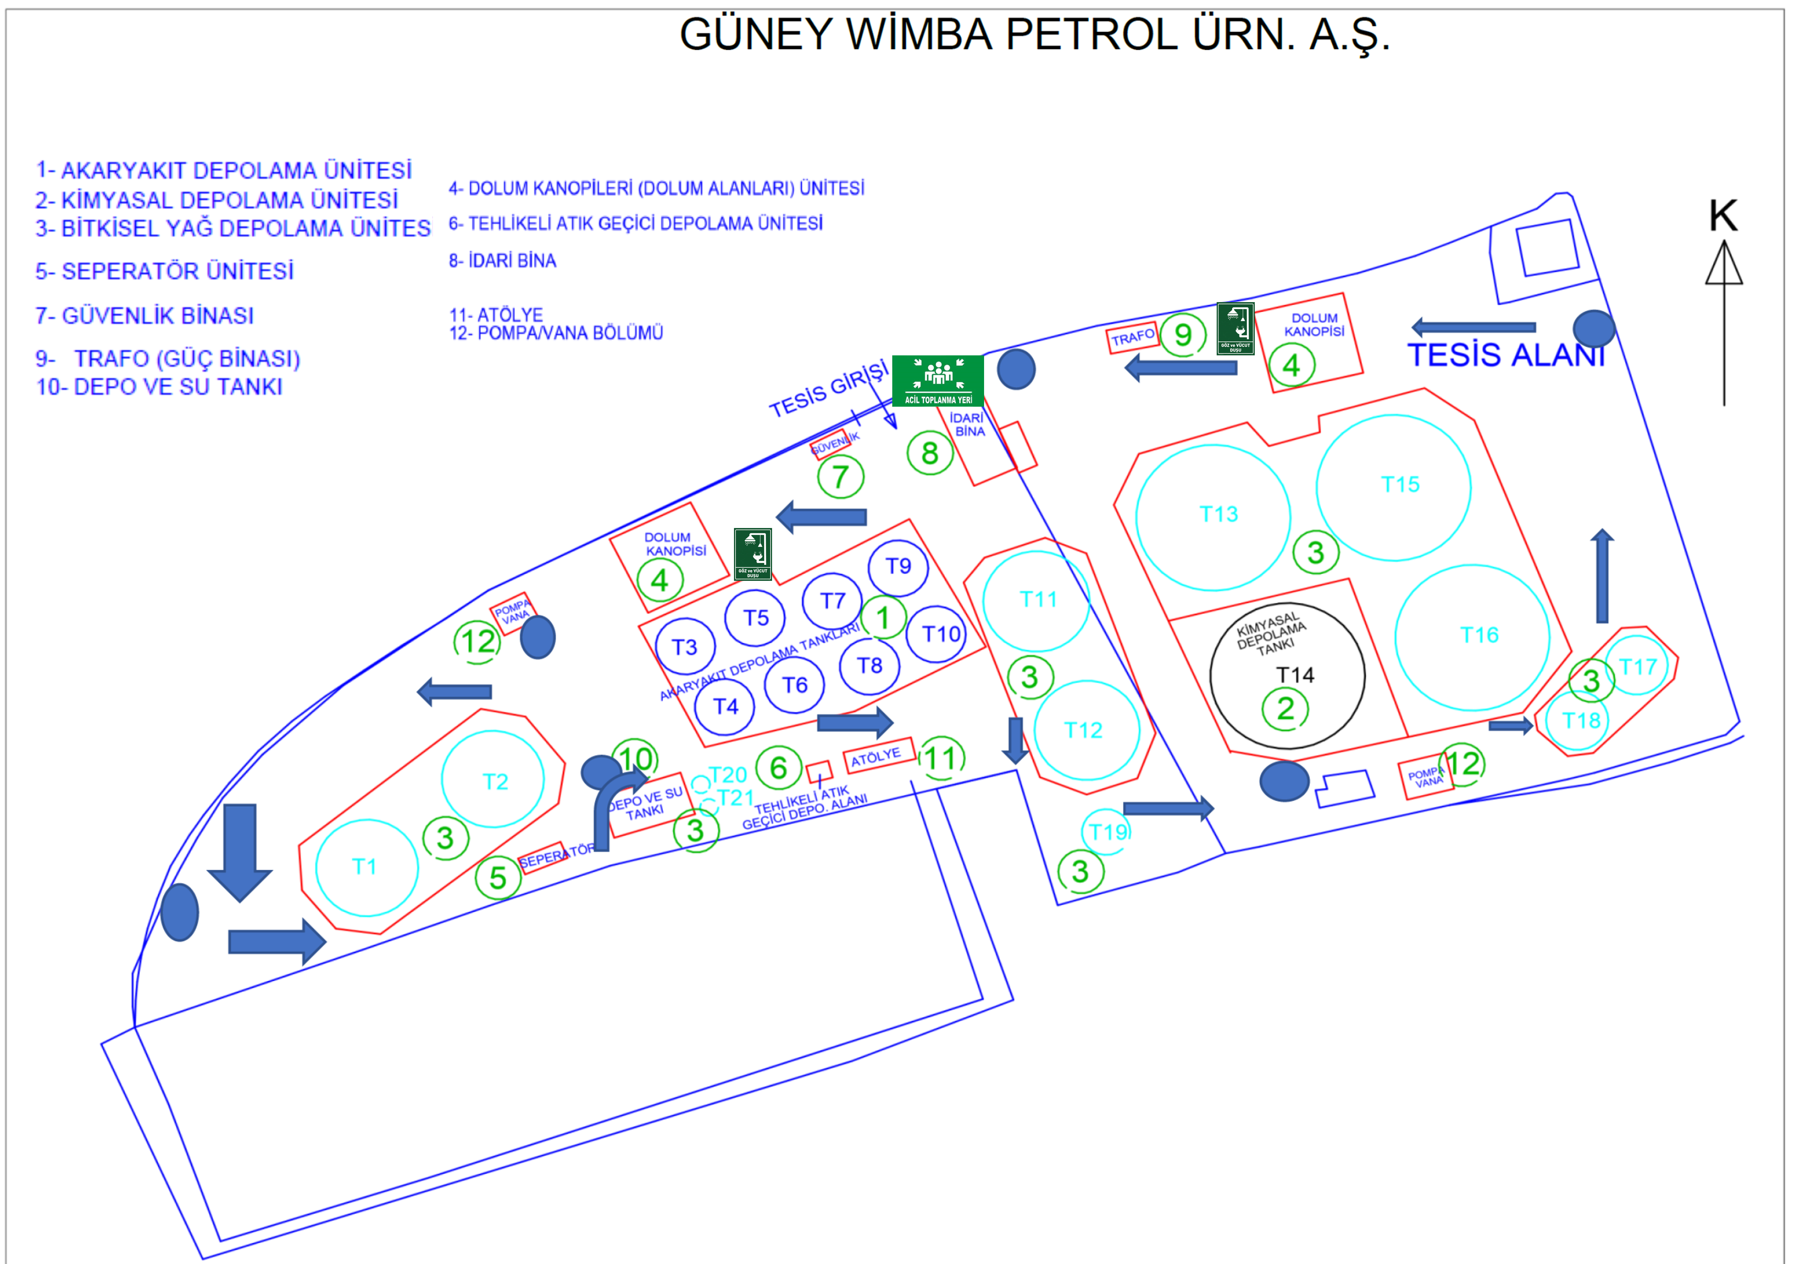

ANNEX-2 IN-FACILITY AND OUTSIDE COMMUNICATION LIST

RELEVANT AUTHORITY | COMMUNICATION INFORMATION
Iskenderun Port Authority | 0 326 614 11 92
Fire Department | 112
First aid | 112
Gendarme | 112
Hatay  Metropolitan Municipality | 0 326 214 91 90
Dörtyol Municipality | 444 7 712
Provincial Directorate of Environment | 0326 216 0606
Coast Guard | 112
Most Windowsill | 0532 138 35 99

ANNEX-3 ORGANIZATION CHART
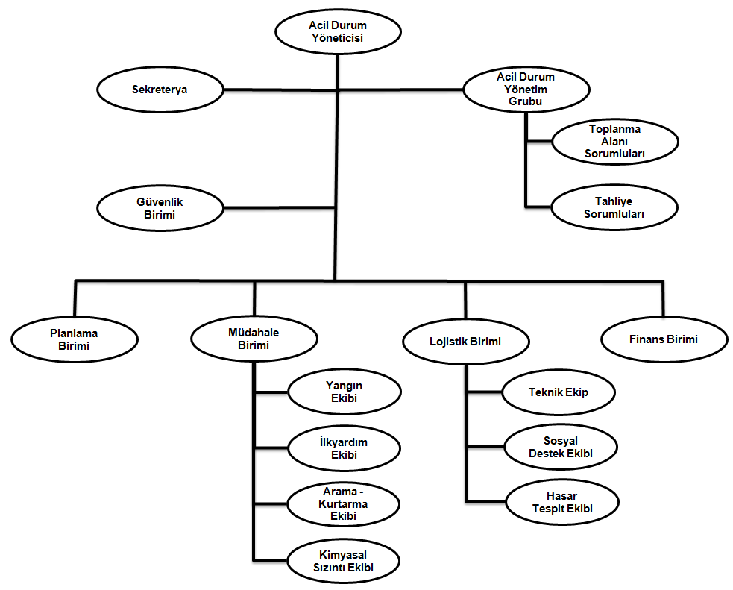

ANNEX-4 DANGEROUS MATERIAL INCIDENT NOTIFICATION FORM

Issue number - Date
Company / Institution
Sender |  | CONTACT INFORMATION
as required
PORT FACILITY
“ DANGEROUS MATERIAL INCIDENT NOTIFICATION”
HISTORY:
1. When the accident occurred,
2. If known, how the accident occurred and its cause,
3. The place where the accident occurred (coastal facility and/or ship), its position and area of influence, ç) If there is a ship involved in the accident, its information (name, flag, IMO number, owner, operator, cargo
and amount, captain's name and similar information),
4. Meteorological conditions,

5. UN number, proper transport name (legislation specified in the definition of dangerous goods will be taken as basis) and quantity of the dangerous goods,
Hazard class of the dangerous substance or sub-hazard section, if any,
Packaging group of the dangerous substance, if any,
Additional risks of the dangerous substance, such as marine pollutants, if any,
Marking and label details of the dangerous substance,
The characteristics and number of the packaging, cargo transport unit and container in which the dangerous substance is carried, if any,
Manufacturer, sender, carrier and receiver of the dangerous substance
6. The extent of damage/pollution occurring, ,

7. Number of dead and injured in the accident (if any),

8. How the accident was intervened,

9. From which organizations assistance is requested,

10. Other ships or neighboring facilities that may be affected by the accident,

PREPARED BY:

Name and surname :
Mission:
Signature :

ANNEX-5 EMERGENCY INTERVENTION AND FIRST AID GUIDE

Loads Handled at Our Port Facility
In our Shore Facility, Hazardous Liquid Bulk Cargoes such as Diesel (UN 1202), Gasoline (UN 1203) and Vegetable Oil within the scope of the IBC Code are handled.

Ems And Mfag Usage Procedure
- AIM

The purpose of this procedure is to determine appropriate emergency response methods using IMDG Code EMS charts in case of fire or leakage that may occur as a result of an accident in any cargo transport unit containing hazardous materials within the facility. When such accidents occur, it is to ensure that employees affected by hazardous substances intervene within the framework of the MFAG charts given in the IMDG Code trainings by professional first aid and/or the port's health units and other port and facility employees who reach the victimized employee until the ambulance arrives. The first medical units to arrive at the scene of the incident should be informed about the possible intervention.

- SCOPE

This procedure covers all maritime hazardous material activity centers and all areas where maritime hazardous material operations are carried out. This procedure has been created for the methods to be followed in accidents that may be caused or involved by dangerous substances in our facilities when hazardous materials are to be handled, if permitted, and the first aid to be applied to the injured within the scope of MFAG.

Methods to be followed in this procedure IMDG Code books; Prepared within the scope of Volume 2 and Supplementary Volume.

- RESPONSIBILITIES

Responding to an emergency using EMS charts. Employees who have received IMDG Code General Awareness and Task Oriented Training and have a Fire Certificate, and employees who have received IMDG Code General Awareness and Task Oriented Training and have a First Aid Certificate are responsible for knowing and applying the rules written in this procedure. MFAG should be used in very urgent situations and only when it is not possible to wait for the professional healthcare team to arrive. Operation managers and managers are responsible for its implementation.

In case of emergency, third parties such as health units, fire brigade and emergency teams coming from outside the facility are required to comply with the instructions specified in these charts.

Personnel who will work in hazardous material handling activities are required to receive General Awareness, Task Oriented, Safety and Fire Training regarding their areas of duty. Personnel will not be able to take part in hazardous materials handling activities without receiving the necessary training.

- DEFINITIONS

Port Area: Sea and coastal areas that include all coastal facilities and anchorage areas where all kinds of port operations and activities are carried out and where customs, agency and similar services are provided.

Dangerous Cargo List: It is the list in Chapter 3 of IMDG Code Volume 2. It is a table containing all the detailed information about dangerous cargoes according to their UN Number.

EMS Charts: These are emergency charts that should be used in cases of fire and leakage, the details of which are specified in the IMDG Code annex, according to the codes in the Dangerous Cargo List.

MFAG (Medical First Aid Guide): Medical First Aid Guide; These are emergency charts, the details of which are specified in the IMDG Code annex, in which the diagnosis and intervention methods to be applied to people who have health problems caused by hazardous substances are specified.

IMDG Code: International Maritime Dangerous Goods Code. It is a set of rules managed by the International Maritime Organization (IMO) that standardizes the regulations required for the transportation of dangerous goods by sea.

UN Number: It is the four-digit United Nations number of the dangerous cargo.

IMO (International Maritime Organization): International Maritime Organization

WHO (World Health Organization): World Health Organization

ILO (International Labor Organization): International Labor Organization

- APPLICATION

- Using the EMS Guide

Dangerous cargoes stored and/or handled during loading or unloading during the operation or in the port area have many different risks.

Dangerous loads cause harm to the facility, equipment, human health and the environment. The characteristic of most hazardous substances is that they are flammable. In this context, the most common and most likely risks among all risks are the burning and leakage or spillage of hazardous substances.

Within the scope of the IMDG Code, the methods to be followed when dangers such as fire or leakage occur in our facility are stated below:

- For appropriate intervention, it is critical to identify the hazardous loads involved in the fire or leak as soon as possible.

- Cargo designations are made through UN numbers. The UN number of the dangerous cargo is included in the IMDG Code Dangerous Goods List (DGL).

- UN Numbers can be found from the labels/plates of dangerous goods, from the preliminary notification made by the agency, customer or cargo person, or if this is not possible, from the storage/loading plan on the ship.

- Once the UN Number is learned, the relevant tables can be accessed according to the codes in the 15th column of the Dangerous Goods List in IMDG Code 2 Volume.

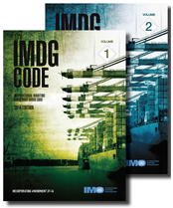IMDG Code Volume 1 and Volume 2

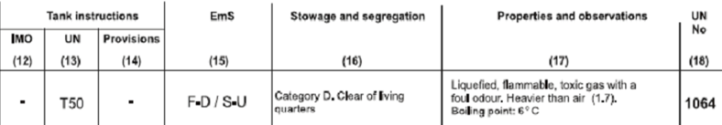

The code starting with “F” indicates the fire chart; F is the first letter of the English word Fire.
Code starting with “S” indicates the leak schedule; S is the first letter of the English word Spillage.

- The codes of the intervention methods corresponding to the UN number are found in the EMS Charts in the IMDG Code Supplementary Volume. When you go to the charts in the guide for these codes, you can access detailed intervention methods and information.

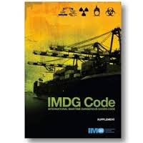IMDG Code Supplementary Volume (Supplement)

- The EMS Schedules include a total of 10 Fire Schedules, one of which is the General Fire Plan (FA) that addresses specific hazardous loads, and the other nine specific to various hazardous materials (FB to F-J) and a total of 26 Leak/Spill Emergency Schedules.

- The emergency charts for Fire and Leak given in the EMS Guide should be used together with the IMO Medical First Aid Guide (MFAG). Each chart; Contains required special emergency equipment, above-deck and below-deck emergency procedures and procedures, and relevant instructions for special cargo.

- The titles of the relevant Fire (F) and Leak (S) charts are as follows:

F – A General Fire Schedule
F – B Explosive Substances and Objects
F – C Non-Flammable Gases
F – D Flammable Gases
F – E Flammable Substances That Do Not React with Water
F – F Temperature Controlled Self-Reactive Substances and Organic Peroxides
F – G Substances that React with Water
F – H Explosive Potential Oxidizing Substances
F – I Radioactive Substances
F – J Self-Reactive Substances and Organic Peroxides Not Requiring Temperature Control

S – A Toxic substances
S – B Corrosive substances
S – C Corrosive substances with flammable properties
S – D Flammable liquid substances
S – E Flammable liquid substances floating on water (with a specific gravity less than water)
S – F Water-soluble marine pollutants
S – G Flammable solids and self-reactive substances
S – H Flammable solids (molten)
S – I Flammable solids (repackaging possible)
S – J Wetted explosives and absolutely self-heating substances
S – K Temperature controlled self-reactive substances
S – L Substances that spontaneously combust in contact with water
S – M Substances at risk of spontaneous combustion
S – N Substances that react violently in contact with water
S – O Substances that are dangerous in contact with water (non-collectible)
S – P Substances that are hazardous in contact with water (possible to collect)
S–Q Oxidizing substances
S – R Organic peroxides
S – S Radioactive substances
S – T Biohazardous hazardous substances
S – U Gases (flammable, toxic or corrosive)
S – V Gases (non-flammable and non-toxic)
S – W Oxidizing gases
S – X Explosives
S – Y Explosive chemicals
S – Z Poisonous explosives

- Using the MFAG Guide

In this section, the aim of the IMO/WHO/ILO Medical First Aid Guide (MFAG) for Accidents Involving Dangerous Cargoes is to provide the necessary recommendations for the diagnosis and initial treatment of chemical poisonings on ships, within the limits of the possibilities available at sea.
IMO/WHO/ILO Medical First Aid Guide (MFAG) is included in the IMDG Code Supplementary Volume. The Guidance published by the World Health Organization (WHO) forms the Chemicals Supplement of the International Guide for Ships (IMGS).
Medical First Aid Guide (MFAG) addresses the substances and materials covered in the IMDG Code and the materials in Annex B of the Solid Bulk Cargo Code (IMSBC Code).
The Medical First Aid Guide (MFAG) provides general information regarding specific hazardous effects that may be encountered.
In case of any exposure, start with emergency action and follow the advice given. User convenience and easy access to advice in case of emergency There are three steps to achieve it :

1. Emergency Action and Diagnosis
- It starts from here.

2. Tables
- Contains brief information for special situations.

3. Attachments
- Detailed information includes list of drugs, list of chemicals in tables.

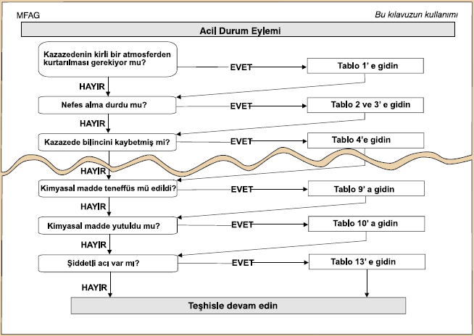
Within the framework of the questions given in the first section, you can navigate through the user manual from top to bottom, simply by answering "yes" or "no". If the answer to the diagnostic question is "yes", go to the table number on the right; if "no", go to the diagnostic question below.

There are 20 tables guided by the contingency schema.
1- Rescue
- CPR (Cardio Pulmonary Resuscitation; Heart Massage)
- Giving oxygen
- Disorders of consciousness due to chemicals
- etc
Symptoms and treatments are given under headings such as.

Tables 16-20 are devoted to specific chemicals. These:
16- Hydrofluoric Acid and Hydrogen Fluoride
17- Organophosphate and Carbamate Insecticides
18- Cyanides
19- Methyl Alcohol and Ethylene Glycol
20- They are Radioactive Materials.
In addition, the sections that will be used visually should be followed in order to easily understand the treatment application.
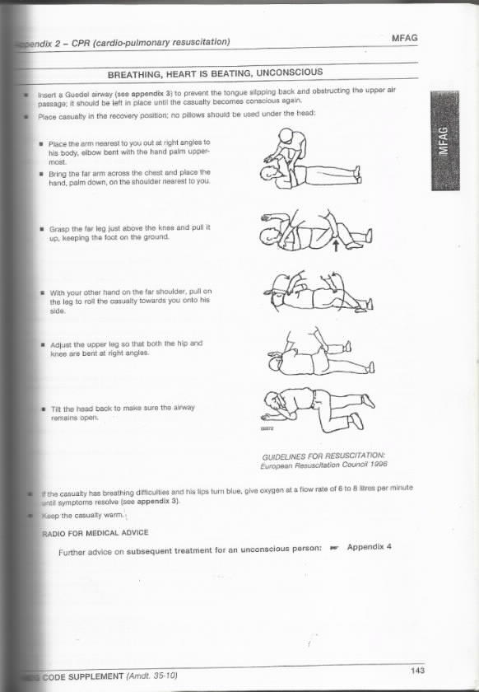
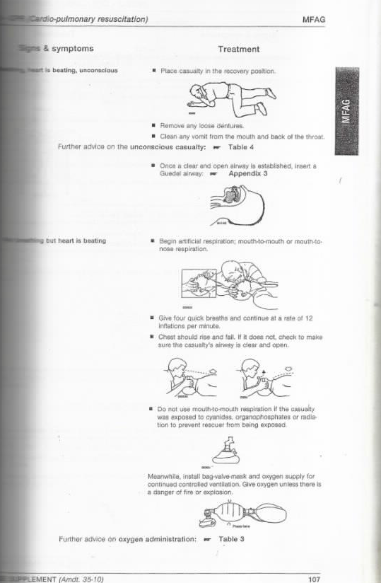
If the relevant personnel has not received IMDG Code Task-Relevant Training, does not have a First Aid Certificate, is not physically and psychologically ready for medical intervention or cannot handle this type of intervention, and knows that the professional health unit will reach the scene of the incident and the injured person in a very short time, they should not intervene in the incident .

It should not be forgotten that; Incorrect and/or inadequate interventions will further increase the existing risk. In such a case, the supervisors in the field and the health unit should be notified as soon as possible.
- RELATED DOCUMENTS
IMDG Code Book - Volume 2
IMDG Code Book - Supplementary Volume

Emergency Response and First Aid Guide to Use When SDS Information Cannot Be Accessed

GUIDE | 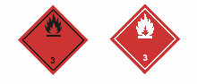
Flammable liquids (polar/water-soluble)
POTENTIAL HAZARDS
FIRE OR EXPLOSION
HIGHLY FLAMMABLE: easily ignited by heat, sparks and fire
• Vapor may form explosive mixtures with air.
• Vapor may reach ignition sources and ignite.
Many vapors are heavier than air. They spread throughout the ground and collect in low or closed areas (sewers, basements, tanks).
• Steam explosion may cause danger indoors, outdoors or sewers.
• Substances marked (P) can polymerize on a large scale when heated or involved in a fire.
• Flow into sewers may present a fire or explosion hazard.
• The tank/container may explode when heated.
• Many liquids are lighter than water.
HEALTH
• Smoke can be irritating.
• Inhalation or contact with material may be irritating or burn to skin and eyes.
• Fire may produce irritating, corrosive and/or toxic gases.
• Vapor may cause dizziness and suffocation.
• Flow or spread of water under fire control may cause pollution.
PUBLIC SAFETY
• As an emergency measure, isolate spills and leaks for at least 50 meters from all directions.
• Keep unauthorized people away.
• Stand against the wind.
• Avoid low places.
• Ventilate closed areas before entering
PROTECTIVE CLOTHING
• Wear a positive pressure self-contained breathing apparatus (SCBA).
• Structural firefighters' protective clothing provides limited protection in fire situations.
EVACUATION
Large Spill
• Consider evacuating at least 300 meters to the wind direction.
Fire
• If a tank or tanker is involved in a fire, isolate it for 800 meters in all directions. Also consider the first evacuation 800 meters in each direction.

GUIDE
Flammable liquids (polar/water-soluble)
EMERGENCY INTERVENTION
FIRE
CAUTION: All these products have a very low flash point. Using water spray may be ineffective when dealing with a fire.
Small Fire
• Dry chemical CO2, water spray or alcohol resistant foam.
Great Fire
• Water spray, fog or alcohol resistant foam.
• Do not use straight streams.
• If you can do it without risk, move the tank/containers from the fire area.
Fire involving Tanks or Car/Trailer Loads
• Try to prevent the fire from the maximum distance or use unmanned hose holders or regulator nozzles.
• Cool the tank/containers with a sufficient amount of water until the fire is extinguished.
• When the sounds of the tank safety equipment increase or the tank changes color, retreat immediately.
• ALWAYS stay away from tanks lost in fire.
• For large fires, use unmanned hose holders or regulator nozzles. If this is not possible, retreat from the area and allow the fire to flare up.
SPILL OR LEAK
• DESTROY all flammable sources.
• All equipment used when handling the product must be grounded.
• Do not walk on or touch spilled material.
• If you can stop the leak without risk, do it.
• Prevent entry into waterways, sewers, basements or closed areas.
• Vapor suppressor foam can be used to reduce vapor.
• Absorb or cover with dry soil, sand or other non-flammable materials.
• Use clean non-shiny tools to collect the absorbed material.
Big Rash
• For subsequent disposal, dig a trench and cover it with wet sand or soil.
• Water spray can reduce vapor; but it may not prevent ignition in closed areas.
FIRST AID
• Take the victim to fresh air.
• Call emergency medical services.
• If the victim cannot breathe, give artificial respiration.
• If breathing is difficult, give oxygen.
• Throw away or isolate contaminated clothing and shoes.
• If there is contact with the substance, clean the skin and eyes with water for 20 minutes.
• Wash the skin with soap and water.
• In case of burns, cool the skin with water as much as possible. Do not remove clothes if they are stuck to the skin.
• Keep the victim warm and quiet.
• Make sure that healthcare personnel are informed about the substances contained in it and ensure that they pay the necessary attention to protect themselves.

